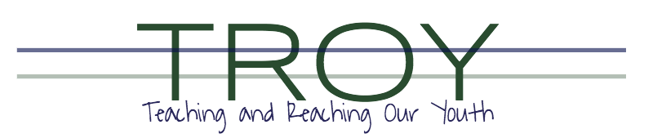

TROY School Employment Opportunity:
POSITION: Resource / Behavior Skills Assistant
BEGINS: August 15, 2022
Part Time up to 27 hours per week
Requirements/Skills:
- Must work well in a team environment
- Previous experience working with students who have behavioral challenges or special needs
- Proactive individual who takes initiative in ensuring student needs are met
- Must have a love of working with a variety of students
- Associate degree preferred but not required

Apply: Please submit interest for position by forwarding resume to: office@troyalternativeschool.com

Deadline: August 1, 2022

TROY School does not discriminate on the basis of religion, race, color, national origin, gender, disability, or age in its programs and activities, including employment opportunities.

